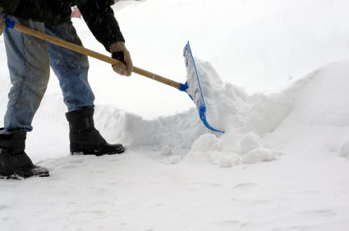
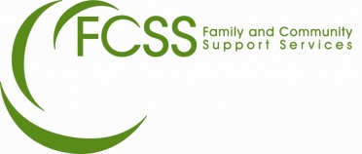
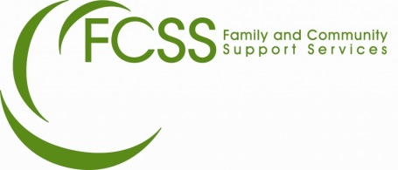
CENTRAL PEACE
SNOW
ANGELS
Central Peace Family and Community Support Services
4202 50th Ave.
Spirit River, AB
Phone: 780-864-3500
Email: FCSS@mdspiritriver.ab.ca

HOW DO I VOLUNTEER?
- Call Central Peace FCSS at 780-864-3500, email fcss@mdspiritriver.ab.ca or stop by the M.D. of Spirit River office, 4202 50th St. to request an application package.
- Complete and return the application.
- Volunteers will be added to our volunteer participant list.
- We will contact you to discuss the match.

WHAT IS IT?
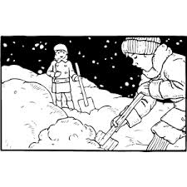
The Snow Angels Program is a volunteer service program where individuals, organizations, businesses, families and groups of youth can commit to removing snow from the sidewalks and driveways for residents in need.

WHO CAN PARTICIPATE?
Residents who are eligible:
Seniors or individuals who are experiencing a disruption in their ability to remove snow. The program is offered to residents based on Volunteer availability. Must reside in the town of Spirit River or village of Rycroft.
Volunteers:
People of all ages, individuals, organizations, businesses, classrooms, families, church groups and groups of youth. The program runs from the first snow fall to the end of the snow season in each year.

WHY VOLUNTEER?

Shoveling someone’s driveway or sidewalk is a rewarding and healthy opportunity for citizens of all ages to enjoy the outdoors while making a personal contribution to improving the quality of life of another in need.

Involvement in this program fosters a sense of ownership and goodwill, encourages civic responsibility and pride in the community and builds appreciation and connection between citizens of all ages. Studies have shown that when citizens actively work together or each other, crime decreases, health improves, resources can be redistributed and quality of life becomes better for all.

WHAT DO I NEED TO PARTICIPATE?
A desire to help a neighbour in need, fill out an application and you will be matched to someone in your area.
We will make sure that everyone who wants to shovel will get paired with a resident in need, even if it is a one-time only commitment.
If you have a favourite shovel or snow blower you are more than welcome to use them but usually the resident will be expected to supply a shovel.

